**Into the Wild Yam Thicket: the ongoing entanglement of *Dioscorea villosa* and reproductive health**

Kira Clingen

The slender leaves of a specimen of *Dioscorea villosa* are pressed, preserved, labeled and stored in the Harvard University Herbaria, collected in Massachusetts in 1903.[1] The winged seedpods are flattened between the leaves, and the vine dried, turning from a bright, light green to faded brown. Though the herbaceous plant, informally known as wild yam, can grow up to 30 feet, the herbarium sample is much shorter, coiled onto itself to fit onto the standardized paper for botanists and other researchers to study.

While the plant is native and widespread across the eastern United States, the roots, which are omitted from the sample, have been used in indigenous and modern medicine for hundreds of years, and have reshaped landscapes and water bodies across the globe.[2]

**Representing the Roots**

Long before the herbaria sample was plastered to a paper sheet, in 1552, Jacobo de Grado, a friar in New Spain wrote and translated the *Libellus de Medicinalibus Indorum Herbis*, also known as the Badianus Manuscript.[3] The manuscript details the medicinal properties of plants used by the Aztec people. In this botanical archive, *Dioscorea villosa*, called macayelli in Nahautl, is referenced as an analgesic, or pain reducer, and drawn balanced between a three tuber root system underground and a complex vine laden with flowers and winged seed pods, which the plant uses to reproduce with help from flies in the genus *Syrphidae*.[4]

The roots and leaves are drawn with an equal emphasis. From its representation, the reader understands that its medicinal qualities derive from the whole plant, not only what’s visible above ground.

**What’s in a Family Name?**

*Dioscorea villosa* was used by indigenous peoples in central America for centuries before it was catalogued by colonial botanists. In 1796, J.R. Forster published his *Flora Americae Septentrionalis*, which included *Dioscorea villosa* by name, noting a sample in Virginia.[5] The genus Dioscorea itself was first named by colonizers. Charles Plumier, a French botanist, bioprospected the western Caribbean in 1703, and published his results, including species in the genus Dioscorea in *Nova plantarum americanum*.[6] Bioprospecting emerged in the 18th century as European imperialist states and companies sent botanists to the Americas to selectively explore and investigate species for the purpose of finding commercially valuable botanical resources. As Gian Carlo Delgado writes, bioprospecting, “relies on the knowledge of rural and indigenous communities that have established an intimate relationship with nature since precapitalist times.”[7] Botany became another tool of colonial expansion in the 18th century that continues to this day.[8]

Botanists like Plumier relied on local knowledge to collect samples and knowledge of plant species to catalog, and even to inform the nomenclature they used to classify plants. Plumier named the genus *Dioscorea* after the Greek physician and botanist Dioscorides, who published his work on medicinal plants in *De materia media*, an herbal encyclopedia that was used in European medicine from its creation in 1754.[9]

American botanists continued to extract information from indigenous groups and publish about the medicinal uses of the species, and, like the Badianus manuscript, to focus on the uses of the roots. In an 1887 volume of *American medicinal plants: an illustrated and descriptive guide to the American plants used as homeopathic remedies: their history, preparation, chemistry and physical effects*. Charles Frederick Milspaugh identifies additional uses of the plant including treating bilious colic, which we know as gallstones, as a way to induce sweating, cause vomiting and treat coughs. It’s also noted to treat ‘dysmennorhea’ and kindred afflictions, which we know as menstrual cramps.[10] Milspaugh offers a method to extract a tonic from the roots, which are abundant and easy to collect.[11]

Otto Wall recorded the plant’s uses by indigenous communities in temperate climates. In the Great Lakes Region on Meskwaki land, the Meskwaki Nation used the plant to reduce pain during childbirth, and as an analgesic and reproductive aid.[12]

While botanists had written extensively about the medicinal uses of *Dioscorea villosa* throughout the 18th and 19th centuries, the exploitation of Dioscorea, and other species in the genus, accelerated during the 20th century, as western nations raced to develop sex hormones. *Dioscorea villosa*, native to the eastern United States, would become a central figure in the global development of the birth birth control pill, which relied on massive biopiracy operations in Mexico, where the plant’s medicinal uses were first recorded.

**Degradation: From Marker to the Mexican Landscape**

In 1938, Russell E. Marker, a chemist working at Pennsylvania State University, successfully synthesized progesterone, a sex hormone, from sapogenin, a naturally occurring compound in sarsaparilla, a herbaceous plant native to the eastern United States where Marker was working. Progesterone had been discovered by doctors earlier in the 1930s, who used the sex hormone to treat menstrual disorders and pregnancies. The process, the Marker degradation, was named for him.[13] But synthesizing progesterone from sarsaparilla was prohibitively expensive, and Marker knew he needed a different natural resource to make progesterone more affordable. The answer came to him from Japanese colleagues, who discovered a compound called diosgenin, which they extracted from the roots of *Dioscorea tokoro*, a wild yam species abundant in eastern Asia.[14] Their paper sent Marker to the Penn State library to study botany in search of a widely distributed source of diosgenin. Marker found his answer outside his laboratory in the roots of *Dioscorea villosa*.

Marker was not a botanist, nor was he particularly interested in plants. Yet, in 1940, he published that he had successfully extracted “extracted the powdered rhizomes of *Dioscorea villosa* with a procedure similar to that used in the isolation of sarsapogenin.”[15] He compared a sample of diosgenin that his Japanese colleagues sent, produced from *Dioscorea tokoro* to confirm his results. He successfully produced progesterone from diosgenin that same year. Marker’s experiments confirmed that the genus *Dioscorea* was a readily available source of diosgenin, which would revolutionize the expensive production of progesterone. However, the yield of diosgenin from *Dioscorea villosa* was low, and therefore not economically feasible, so he tried producing the compound from other plants, including Beth plant, or *Trillium erectum* that he gathered on an expedition to North Carolina. On the trip, he noted “the roots are only about the size of your thumb. Collection of one hundred pounds a year would be about the limit.”[16] In 1942, he updated his findings, writing “the easy conversion of diosgenin to progesterone made necessary the investigation of additional plant sources.” He lists eight additional species, all sampled in the eastern United States.[17]

He decided “no plant in northern North American contained sufficient material to be an inexhaustible source of steroids for medicinal purposes,” and set out beyond the eastern United States in search of an economically feasible source of diosgenin, focusing on the genus *Dioscorea*.[18][19] Botanists from Penn State connected him to their networks, and, while spending time with a botanist in Texas, he flipped to a random book by his bedside, where he saw a large, tuberous root. The caption read, “This specimen was collected just where the highway from Mexico to Veracruz, between Orizaba and Cordoba, crosses over the Barranca [gorge] de Metlac.” He left the United States for Mexico in 1941, searching for a species he knew in his extremely limited Spanish as “cabeza de negro.”[20]

World War II shortened Marker’s first collecting trip, and he returned in 1942, and traveled with a Mexican botanist who confirmed the “cabeza de negro” spcecies was a relative of Dioscorea villosa, called *Dioscorea macrostachya*, now called *Dioscorea mexicana*, found in Veracruz in central Mexico.[21][22] After a falling out with the Mexican botanist, Marker, with his limited Spanish, boarded a bus himself for Orizaba, Veracruz. He got off the bus and asked a local shop owner, Alberto Moreno, for specimen. Moreno helped him load two large tubers of “cabeza de negro” onto the bus. His tubers were confiscated on his return trip, and he was only able to bribe a local policeman enough to return one tuber, which he smuggled out of the country, back to his lab at Pennsylvania State University.[23][24]

Marker committed an act of biopiracy in bringing the plant back to the United States. He entered the sovereign state of Mexico with an introductory letter expressing his interest in “working on some hormone projects intimately related to the National Defense [of the United States].”[25] He viewed the plant as a natural resource for drug development, without consideration of the deep-rooted history or indigenous traditions associated with the plant. The species were interchangeable, except for the amount of diosgenin in their roots.[26][27]

In the United States, back at Penn State, he successfully synthesized progesterone from *Dioscorea mexicana*, but without American pharmaceutical interest, he moved to Veracruz and cofounded Syntex Laboratories in Mexico City in 1944, beginning the Mexican steroid industry, which would shape the global industry for years to come.

The Mexican steroid industry also reshaped the Mexican landscape. Over the years, Marker collected twenty forms of Dioscorea throughout Mexico. He readily abandoned Dioscorea mexicana for *Dioscorea composita*, known locally as barbasco, for its higher diosgenin content.[28] Marker created a set of operations to cultivate and collect wild yams, test the rhizome and produce diosgenin. At its height, Syntex employed 25,000 campesinos, Mexican farmers, to cultivate and harvest wild yam and 3,000 people to produce it.[29] An infrastructure of roads and distribution facilities were established across Veracruz to facilitate the exploitation of barbasco for the pharmaceutical trade.[30] The farmers collected 75,000 tons of roots per year to use in the production of the birth control pill, which was developed over two decades after Marker discovered Dioscorea as an economic source of diosgenin to produce progesterone.[31]

Marker himself was only involved in Syntex for a few years. He permanently moved back to the United States in 1956 after the United States established an embargo against Mexico, accusing the Mexican government and Syntex of monopolizing the market for diosgenin, the source of which was squarely within Mexico’s borders.[32]

**From Plant to Pill**

In 1951, Carl Djerassi, working at Syntex, developed a synthetic progesterone pill, but did not develop it into a contraceptive.[33] The next year, Gregory Pincus, funded by Katherine McCormick and Margaret Sanger of Planned Parenthood and working at the Massachusetts Institute of Technology (MIT), successfully synthesized a two-ingredient estrogen-progesterone pill in 1952. The invention had revolutionary implications for women around the globe.[34]

The clinical trials for the pill could not be conducted at MIT in Massachusetts without incurring a $1000 fine per trial, so the team began medical trials of the pill in Puerto Rico, on a series of trials that have been condemned for their lack of informed consent by today’s standards.[35]

The range of the *Dioscorea* genus expanded as lab tests began around the world through the late 1950s, with scientists breeding tubers with higher diosgenin concentrations to use to manufacture the pill. Around the world, clinical studies in Sri Lanka, the United States, Haiti, Hong Kong, Japan and Mexico began in 1960, and by 1961 half a million women were using the pill to regulate menstruation and pregnancy.[36] Today, the pill is available across the globe, and is one of the most popular forms of contraceptive, despite ongoing attempts to regulate its usage.[37][38]

**Re-Rooting *Dioscorea villosa***

Situating the plant in this entanglement of reproductive hormones, policy and moving into the present, the story of *Dioscorea villosa* and its role in the development of the birth control pill becomes more complex. Global use of the pill has come with side effects, including an influx of progesterone and estrogen, another sex hormone used in many birth control pills, into municipal water systems, which are discharged in the absence of reverse osmosis systems. The estrogen flows through sewers into water bodies across the globe, finally flowing into the ocean and remaking the chemistry of our largest commons at a planetary scale, where increasing synthetic hormone levels impact the fertility of humans, marine and terrestrial animals alike.[39][40]

On land, the plant’s success and distribution has also led to its critical risk, as habitat destruction and over harvesting threaten its existence. *Dioscorea villosa* is commonly harvested for reproductive supplements. The plant deteriorates rapidly after harvest, which privileges low-volume harvesters who supply small amounts, which increases the amount of patchy habitat destruction.[41] *Dioscorea villosa*, and the industry that emerged from Marker’s first proof that progesterone could be synthesized from the genus, has reshaped human life on Earth across scales.

Despite the transformation of the plant from a weedy vine growing on roadsides and in deep thickets to an influential commodity, traded for the chemicals in its roots, western botanists continue to represent *Dioscorea* as a leafy specimen on herbaria sheets. This kind of botanical representation, for a plant that has been at the center of bioprospecting campaigns for almost a century, fails to communicate the ongoing entanglement of a plant exploited, not for botanical interest, but economic gain. By redrawing the plant with its attendant agents - from the mortal and pestle that indigenous women used to create medicine, to the trowels used by Marker to collect the root, to the laboratory equipment used to isolate diosgenin, and the birth control pill that resulted from Marker’s experiments in the genus, with diosgenin flowing from its roots to the global oceans, we understand the reach of the plant, from the eastern United States around the globe.

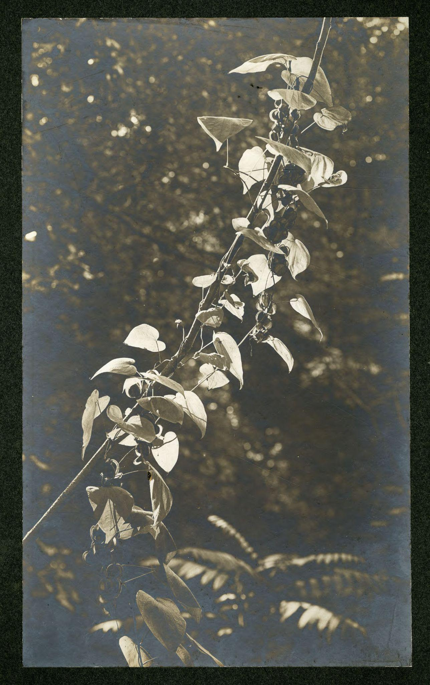

Hibbard, C.J. “Dioscorea villosa.” University of Minnesota: Department of Botany. 1900. Used with permission from the University of Minnesota Archives.

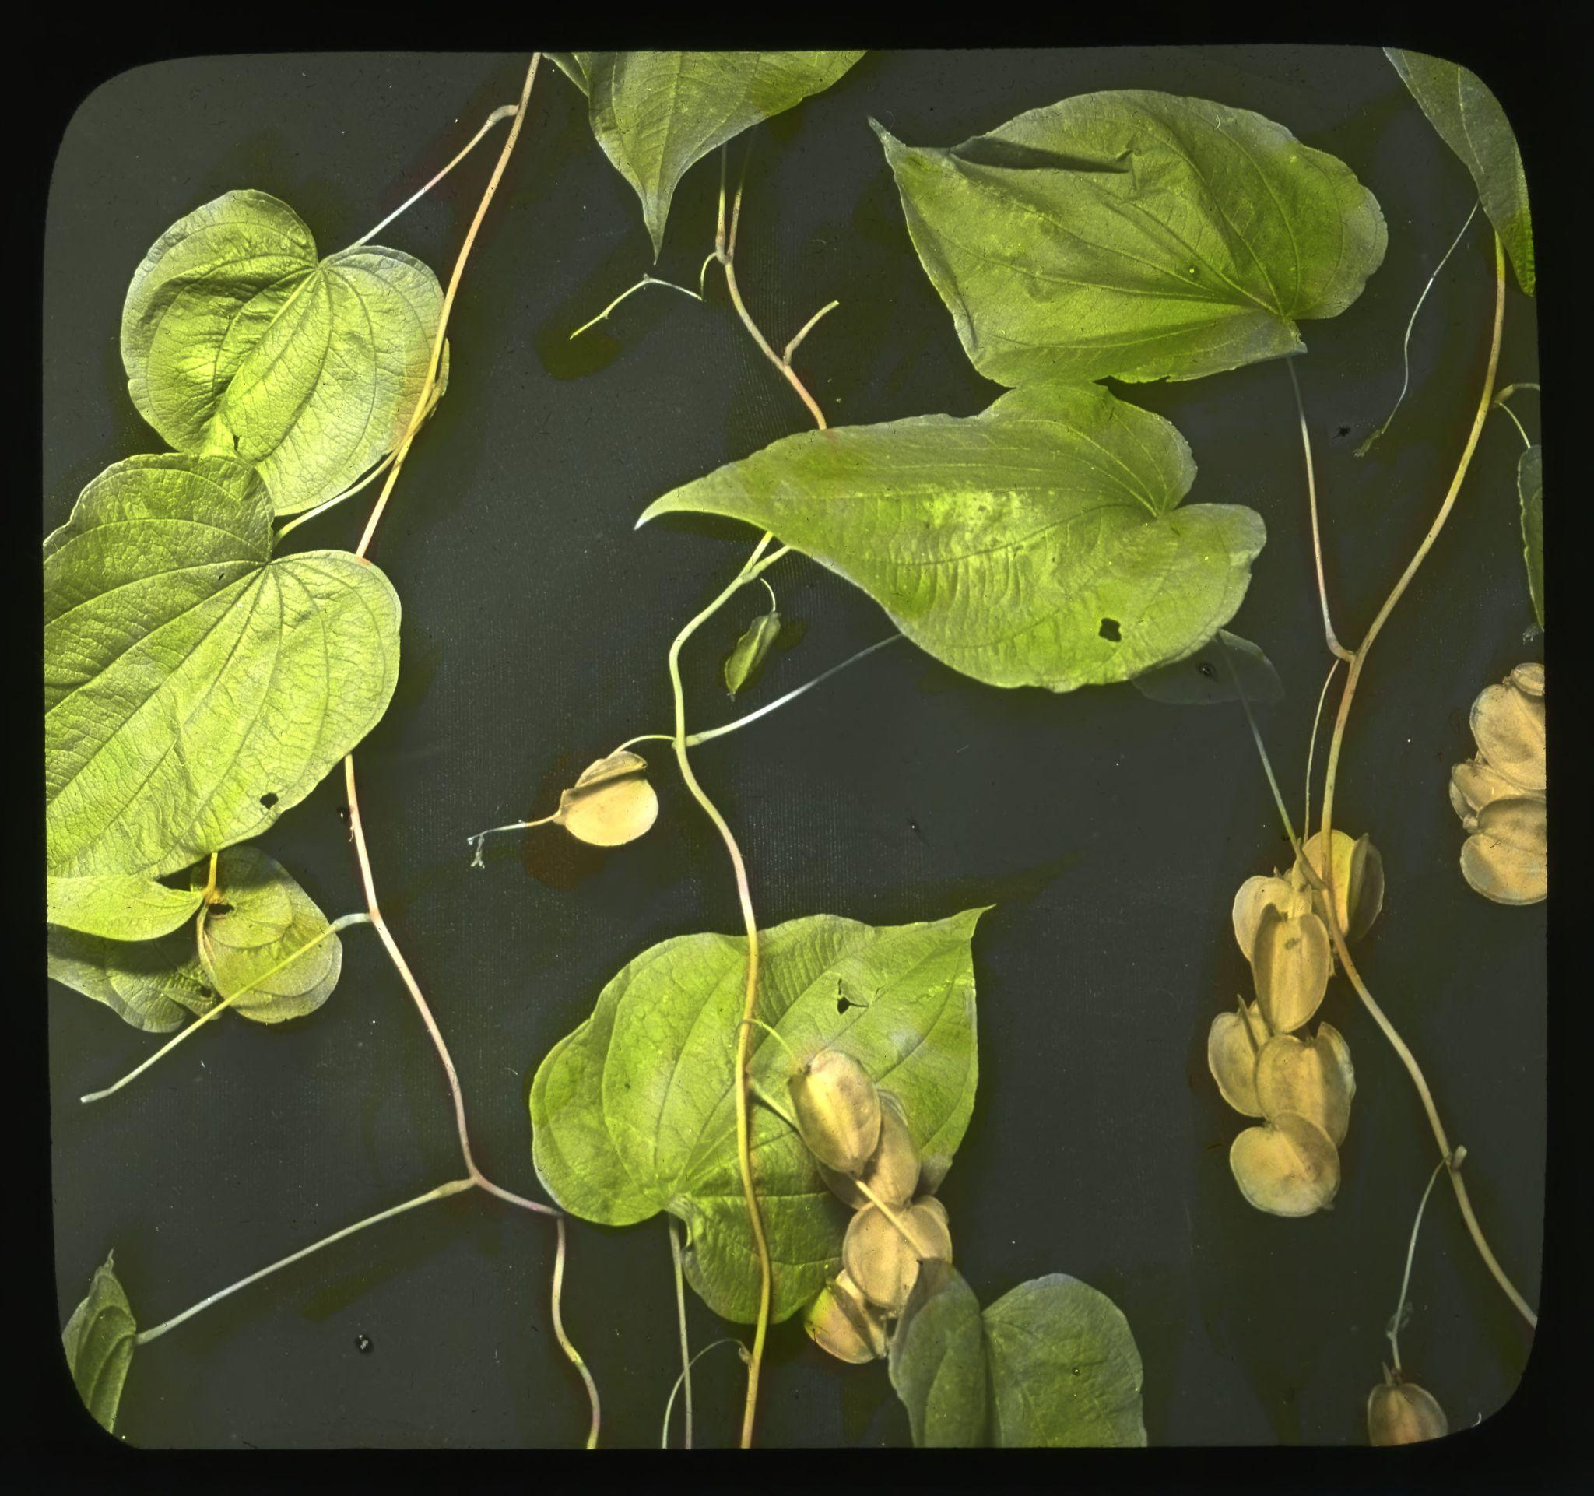

Huff, Ned. “Dioscorea villosa.” University of Minnesota: Department of Botany. 1942. Used with permission from the University of Minnesota Archives.

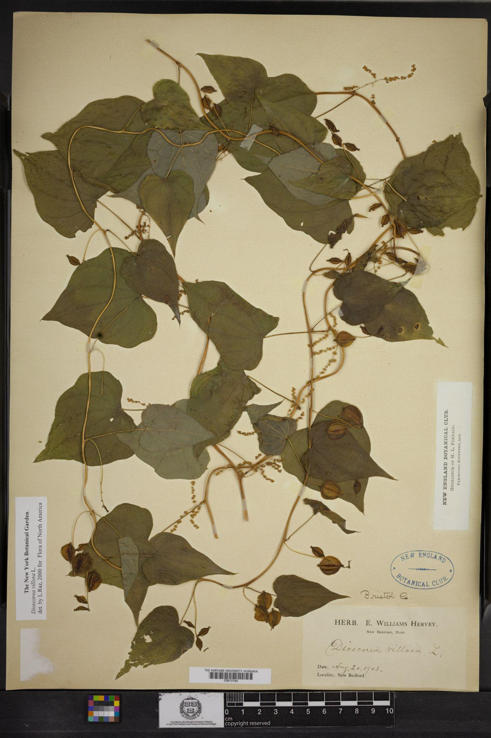

E.W. Hervey. North America: US and Canada (Region): United States of America: Massachusetts: Bristol County: New Bedford. 1903.

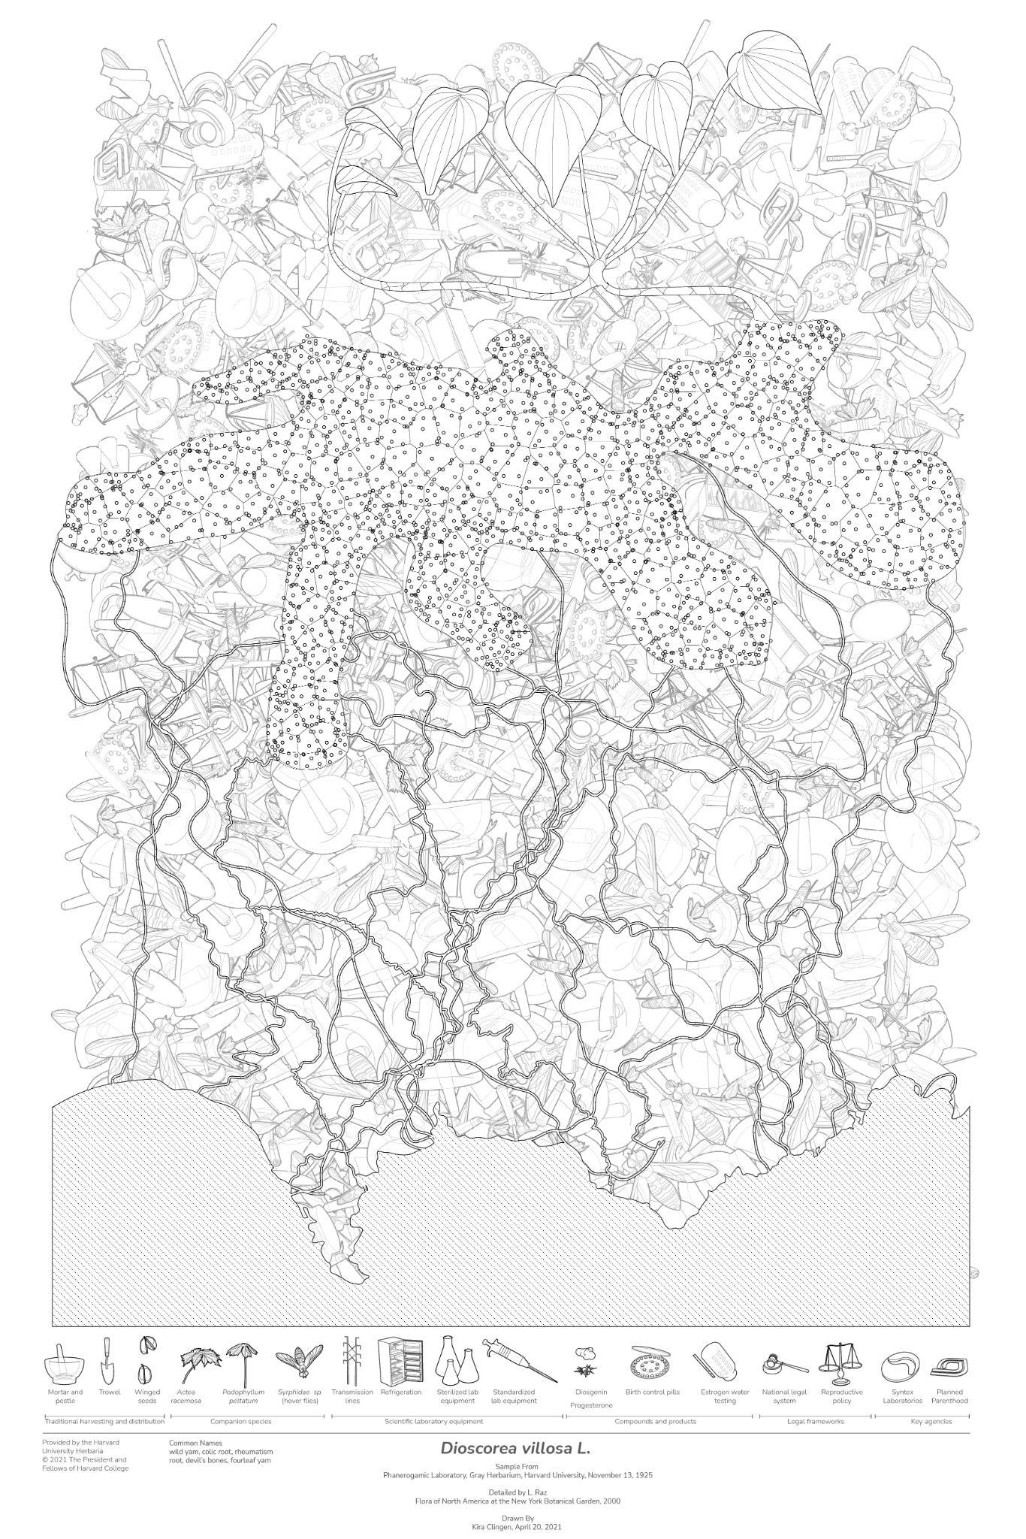

Clingen, Kira. “Updated *Dioscorea villosa* Herbarium Sheet.” 2021.

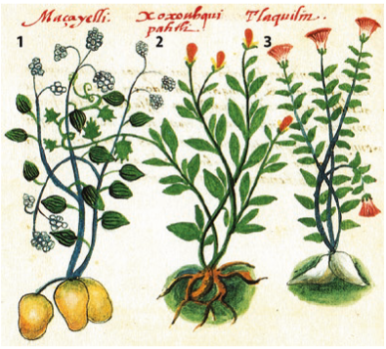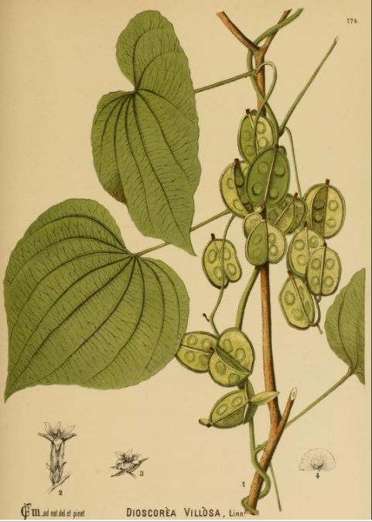

Milspaugh, Charles Frederick. American medicinal plants: an illustrated and descriptive guide to the American plants used as homeopathic remedies: their history, preparation, chemistry and physiological effects. New YorK: Boericke and Tafel, 1878.

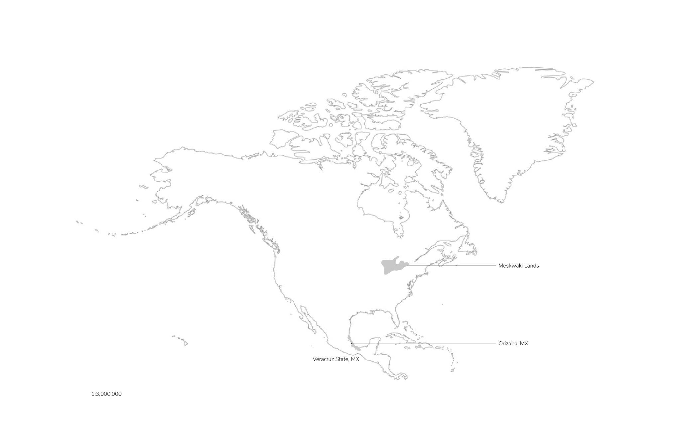

Clingen, Kira. “Map of the Regions Indigenous People were using Dioscorea villosa in the United States.”

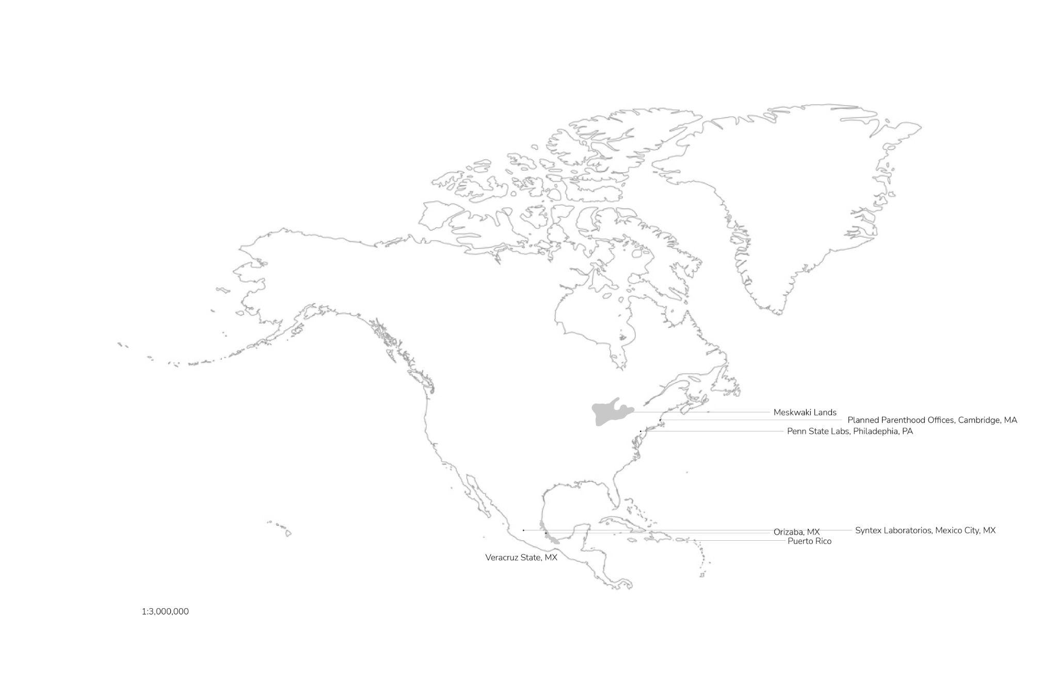

Clingen, Kira. “Map of *Dioscorea villosa’s* world reach.”

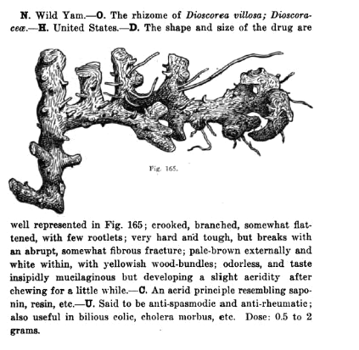

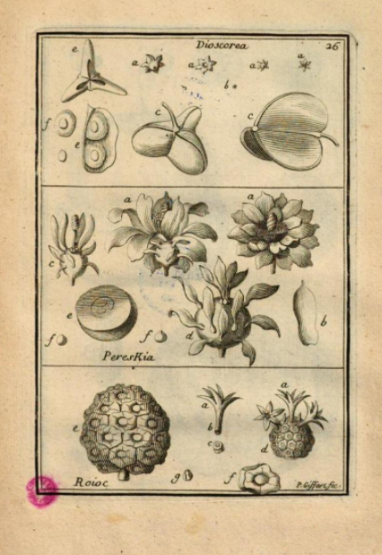

1. E.W. Hervey. North America: US and Canada (Region): United States of America: Massachusetts: Bristol County: New Bedford. 1903.
2. North American Native Plant Society. “Dioscorea villosa, Wild yam.” *North American Native Plant Society*. Accessed March 27, 2021.
3. Tucker, Arthur O. and Jules Janick*. Flora of the Codex Cruz-Badianus*. Cham: Springer International Publishing, 2020, p. 46-47.
4. Tucker, *Flora.* 
5. Forster, J.R. *Flora Americae Septentrionalis.* Boston:B. White, 1771.
6. Plumier, Charles. *Nova plantarum americanum.* Paris: Regis and Regix Scientiatum Academiae Typrographum, 1703.
7. Delgado, Gian Carlo. “Biopiracy and Intellectual Property as the Basis for Biotechnological Development: The Case of Mexico.” *International Journal of Politics, Culture and Society* 16, no. 2 (2002): 297-318.
8. Schiebinger, Londa. *Plants and Empire: Colonial Bioprospecting in the Atlantic World*. Cambridge, MA: Harvard University Press, 2004.
9. Laveaga, Gabriela Soto*. Jungle laboratories: Mexican peasants, national projects and the making of the pill*. Durham: Duke University Press, 2009.
10. Sievers, A.F. *The Herb Hunter’s Guide*. Misc. Publication No. 77. Washington, D.C.: USDA, 1930.
11. Milspaugh, Charles Frederick. American medicinal plants: an illustrated and descriptive guide to the American plants used as homeopathic remedies: their history, preparation, chemistry and physiological effects. New YorK: Boericke and Tafel, 1878.
12. Wall, Otto A. *A Handbook of Pharmacognosy*. St. Louis, MO: C.V. Mosby Co., 1917.
13. American Chemical Society and Sociedad Quimica de Mexico. T*he “Marker Degradation” and the Creation of the Mexico Steroid Hormone Industry 1938-1945*. University Park, PA: American Chemical Society, 1999.
14. Tsukamoto, T., Y. Ueno ad Z. Ota. “Constitution of diosgenin. I. Glucoside of Dioscorea Tokoro Makino.” Journal of the Pharmaceutical Society of Japan 56 (1936): 931-940.
15. Marker, R.E., D.L. Turner, P.R. Ulshafer. “Sterols. CIV. Diosgenin from certain America plants.” Journal of the American Chemical Society 62 (September 1940): 2542-2543.
16. Russell Earl Marker, interviewed by Sturchio, Jeffrey L. in Pennsylvania State University on April 17, 1987. Philadelphia: Science History Institute, n.d. Oral History Transcript 0068.
17. Marker, Russell E., R.B. Wagner and Paul R. Ulshafer. “Sterols. CXLVI. Sapogenins. LX. Some New Sources of Diosgenin.” Journal of American Chemical Society 64 (1942):1283-1285.
18. Lehmann, Pedro. “Early History of Steroid Chemistry in Mexico: the story of three remarkable men.” *Steroids* 57, no. 8 (1992): 403-408.
19. Laveaga,*. Jungle.*
20. Lehmann,”Steroid.”
21. Govaerts, R., Wilkin P. and Saunders, R.M.K. World Checklist of Dioscoreales:Yams and their allies. Kew: The Board of Trustees of the Royal Botanic Gardens, 2007.
22. Laveaga,  *Jungle.* 
23. Lehmann, “Steroid.”
24. American Chemical Society, *Marker*.
25. Laveaga, *Jungle.*
26. Hayden, Cory. *When Nature Goes Public: The Making and Unmaking of Bioprospecting in Mexico.* Princeton: Princeton University Press, 2020.
27. Gereffi, Gary. *The Pharmaceutical Industry and Dependency in the Third World.* Princeton: Princeton University Press, 2017.
28. Marker, “Oral History.”
29. Laveaga,*. Jungle.* 
30. Chapela, Ignacio. “Biodiversity in the Age of Information: A Critical Analysis of Conservation Initiatives Associated with the Discovery of New Pharmaceuticals.” In Biodiversity, Biotechnology, and Sustainable Development in Health and Agriculture: Emerging Connections. Washington, D.C.: Panamerian Health Organization, 1996.
31. Marker, “Oral History.”
32. Hayden, *Nature.* 
33. Syntex. *Syntex Annual Report.* Mexico City: Syntex Laboratorios, 1963.
34. Planned Parenthood. The Birth Control Pill: A History. New York: Planned Parenthood, 2005.
35. Watkins, Elizabeth Siegel. *On the pill: a social history of oral contraceptives, 1950-1970.* Baltimore: John Hopkins University press, 1998.
36. Planned Parenthood. *The Birth Control Pill: A History.* New York: Planned Parenthood, 2005.
37. Zava. “Contraception around the world: interactive map.” Online Doctor. May 5, 2014. Accessed online April 19, 2021.
38. Beauchamp, Zack. “Here’s a map of the countries where the pill is fully subsidized (it includes Iran).” *Vox*. June 30, 2014. Accessed April 19, 2021.
39. Caldwell et al. “An Assessment of Potential Exposure and risk from Estrogens in Drinking Water*.” Environmental Health Perspectives* 118, no. 3 (2010): 338-344.
40. Fisher, Carl, Claudia Martins, Ed George and Pranathi Perati. “Expanded Analysis of Human Hormones in Drinking Water Using Solid-Phase Extraction and Liquid Chromatography Tandem Mass Spectronomy.” ThermoFisher Scientific. 2009.
41. Pengelly, Andrew. “*Dioscorea villosa* L. Wild yam.” *Appalachian Plant Monographs*. Tai Sophia Institute Appalachian Center for Ethnobotanical Studies. 2011.